



**Craig Johnson, Post Commander**

I can’t believe the Summer has come and gone. Once again, your VFW and Auxiliary had a busy but very successful one thanks to our dedicated members, our hardworking Cooties, and our committed Auxiliary. Their efforts are greatly appreciated!

A brief recap:

June began with the Department Convention at our Post Home. A busy weekend but our new home left all very impressed. The VFW riders had their Vets Home ride and picnic. The residents love seeing the bikes but more importantly, the time visiting with our members. We had our first Cruise Night that was hampered by rain. The Red Hawks Veterans Appreciation night had a great turnout.

July saw the RRV Military Appreciation Day and our own Bill Tuff received the Local Hero Award for all of his efforts for the Community, VFW, and our veterans. Congrats Bill!! Our second Cruise Night was a HUGE success. Weather was perfect and everyone was excited to be there. Several members went down to the National Convention in Florida. Thanks Commander Reed for representing our Post and bringing home, yet another Community Service Award. Thank you to all of you that made that happen. We had our first ever Community Picnic at our Post home and POW Plaza. This was a huge success and brought a lot of families to our family friendly Post & Canteen.

August 4th found us back at in Lisbon at the Veterans home. We had a good time grilling burgers and dogs and serving the residents. Thanks to all who participated.

Fall will soon be upon us and there are countless opportunities to get involved and volunteer with the many upcoming activities and events.

Our Post isn’t asking for 40hr’s a week but rather come out and see what fun we have hosting these events and activities. Our Post is successful because of all our many dedicated volunteers chipping in, working together having fun so that we can accomplish our primary mission which is to SERVE VETERANS.

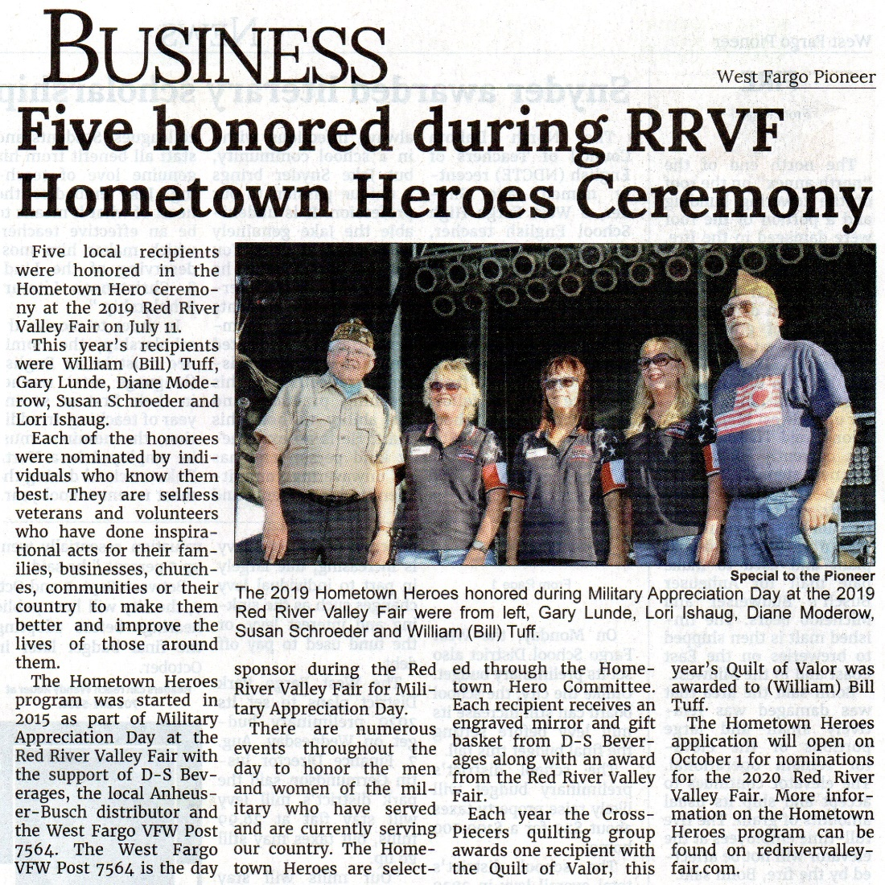

Hometown Hero: Bill Tuff



**Bonnie Kupperion, Auxiliary President**

It’s hard to believe it’s August already, and the National Convention is behind us. Orlando was a great learning experience, with a wonderful group of Friends, and an opportunity to meet many more. The VFW is an inspirational group of people helping our Veterans who gave their all for our Freedom. I was amazed how large of an organization we really are. Thank you to Patty, Joyce, Laretta, and Sheila for all their help and being such great mentors for our Auxiliary and Post. Without all of our members and volunteers we could not exist.

On Sunday July 28th was the community picnic. It was a great success and it was nice to

Have it at the post. I heard many nice comments on our nice new building. With the cloudy

Day it was great to be inside too. Cruise night was a story of it’s own, We made History! The

Biggest “Taco in a Bag” night ever! We had so much fun, thank you to all who participated in

The event. The weather was great and the crowd was huge. Thanks Jess Nelson to your Crew

for the great job organizing this night!

Coming up in August is the Lisbon picnic on the 4th. The Night to Unite is on August 6th

From 5-8 pm. On August 10th we will be having our Fall Training in Jamestown. This will

Be from 8:30 – 4:00. I attended last year and this is a good day to attend to learn a little more

What we are about, and meet people from our state that belong to other Auxiliaries. Our next

Cruise night is August 15th from 4-9, and our National Presidents Visit is on August 28-29.

Have a wonderful rest of your summer and come volunteer when you can! Don’t forget

Hospital Bingo is on August 27th. Our Veterans fought for our freedom! We can play Bingo and

Make Taco’s for them!

Bonnie Kupperion

VFW Post 7564 Auxiliary President

kupperion@netzero.com

701-200-3564

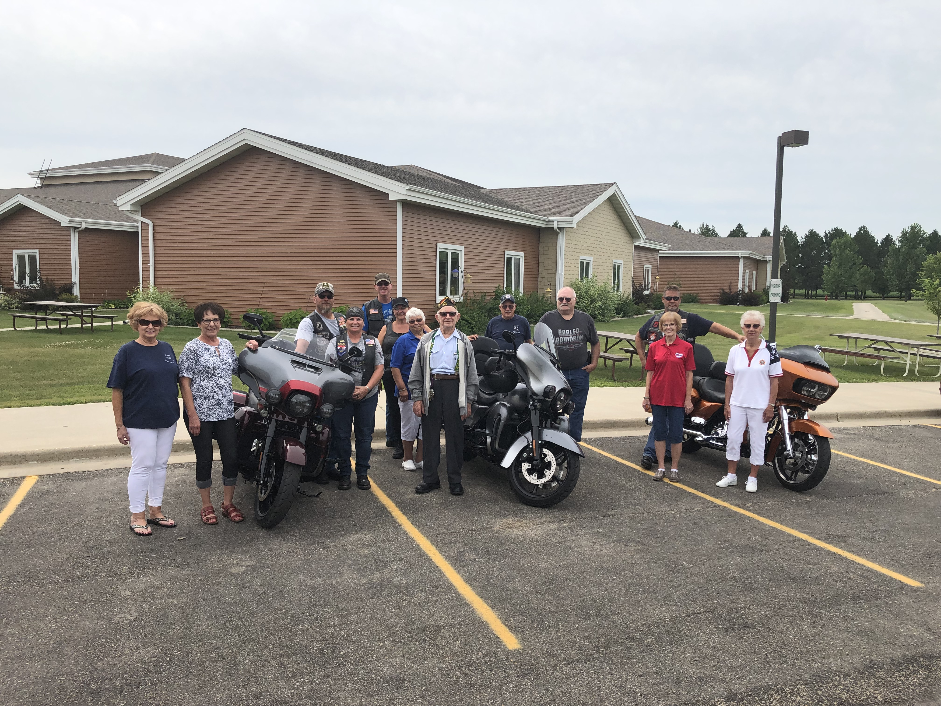

Veterans’ Home Picnic on August 3rd.

**VFW**

VETERANS OF FOREIGN WARS OF THE US

ARTHUR W. JONES * Post No. 7564

444 Sheyenne Street

West Fargo, ND 58078

Telephone: 701-282-4728

**COOTIE CHATTER **

Brad Reed, Seam Squirrel

Hard to believe summer is coming to a close and the spaghetti dinners are around the corner. Cootie meeting will be August 26th and then next meeting will be October 7th. First spaghetti dinner is schedule for September 9th, Teams be looking for the schedule in the mail or your email, pick up a copy at the post.

There will be $5 dollar ticket gun raffle supporting the R.O.S.S. event, drawing will be at R.O.S.S. event on October 26th. Please support this event to help us support the our local Guard and Reserve units Family Readiness Groups.

Be on the lookout for the Cooties’ newsletter, coming soon to you!

Next hospital visit will be August 27th bus leaves at 6:30. “Keep them smiling in sheets of white.”

Thank you everyone!

Brad

To view the VFW and Auxiliary events please visit the Post 7564 website:

<https://vfw7564.org/di/vfw/v2/default.asp?pid=13421&caltype=Post&1=2#CAL>