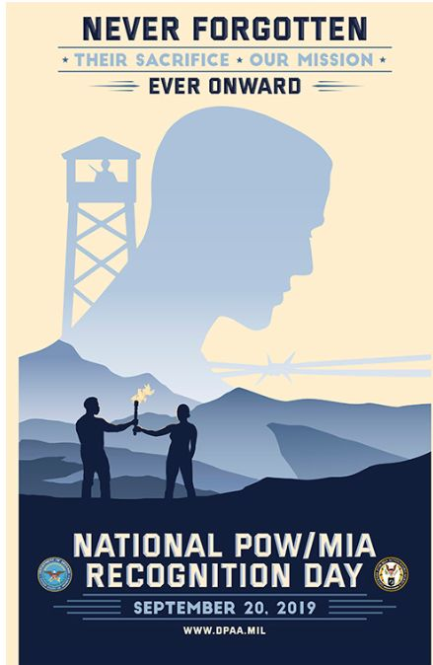
VFW DEPT. OF NORTH DAKOTA
POW/MIA REPORT
AUGUST 18, 2019
THESE 4 VETERANS RETURNED ALIVE FROM NORTH DAKOTA
AS PRISONERS IN NORTH VIETNAM
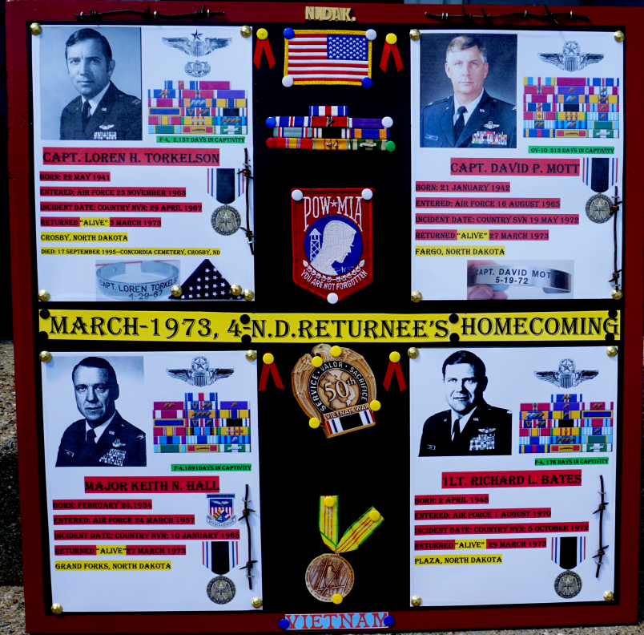

NEW POW/MIA POSTER FOR THIS YEARS POW MIA RECOGNITION DAY
SEPTEMBER 20, 2019

1,587 Americans are now listed by DoD as missing and unaccounted-for from the Vietnam War: Vietnam - 1,246 (VN-443, VS-803); Laos–286; Cambodia-48; Peoples Republic of China territorial waters–7. (These numbers fluctuate due to investigations resulting
Accountability: At the end of the Vietnam War, there reportedly were 2,583 unaccounted-for American prisoners, missing or killed in action/body not recovered. As of July 29, 2019, the Department of Defense lists 1,587 Americans as missing and unaccounted-for, 90% of them in Vietnam or in areas of Cambodia and Laos where Vietnamese operated during the war. A breakdown by year of recovery for the 996 Americans accounted for from Vietnam War-related losses post April 30, 1975 follows:
1965-1974 War years: (recently identified) 2
1974-1975 Winding down USG effort 28
1976-1978 US/SRV normalization negotiations 47
1979-1980 US/SRV talks break down 1
1981-1985 1st Reagan Administration 23
1985-1989 2nd Reagan Administration 168
1989-1993 George H.W. Bush Administration 129
1993-1997 1st Clinton Administration 327
1997-2001 2nd Clinton Administration 57
2001-2004 1st George W. Bush Administration 64
2004-2008 2nd George W. Bush Administration 62
2008-2012 1st Obama Administration 51
2012-2016 2nd Obama Administration 27
2016-2020 Trump Administration 10
NORTH DAKOTA STILL HAS
9--- VETERANS UNACCOUNTED FOR FROM THE VIETNAM WAR

AS I END THIS REPORT I WANT TO THANK COMMANDER RICE FOR APPOINTING ME AS POW/MIA CHAIRMAN FOR 2019-2020 YEAR

DAVID ERBSTOESSER/ CHAIRMAN

