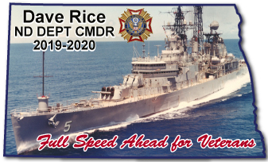 | 2019 – 2020 Commanders Project  Dave Rice  2610 76th Ave N  Fargo, ND 58102  commander@tristateveterans.com  701-866-9085  www.vfwnd.org
North Dakota Veterans of Foreign Wars Department Commander Dave Rice has chosen the VA Hospital and Veterans Honor Flight of ND/MN for his Commanders Project.
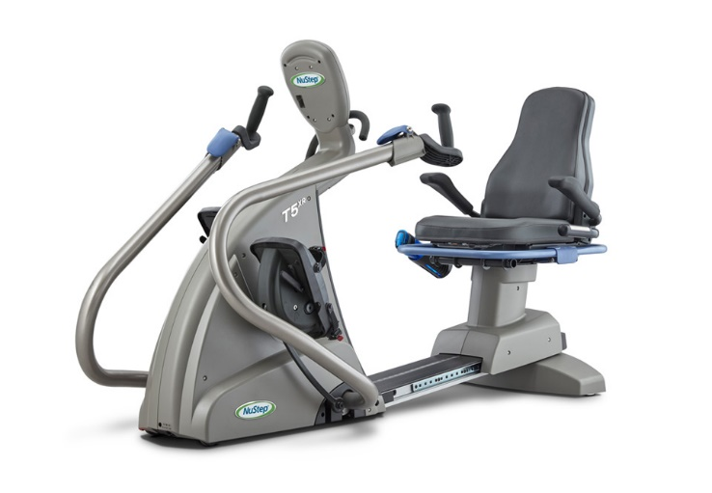 | The Fargo Veterans Administration Health Care System (Fargo VA Hospital) needs exercise equipment for our hospitalized Veterans. The ND VFW would like to provide this exercise equipment for our Veterans hospitalized there. This equipment is not part of the hospitals operating budget thus requires fundraising by our Veterans and Patriotic Americans.
Statement from nursing: This piece of exercise equipment will help all Veterans maintain physical activity, range of motion and strength to upper and lower extremities. It will also provide Veterans with increased enjoyment and variety in exercise options. The equipment will help to improve Veteran moral therefor improving overall quality of care and improving the mental and physical health of the Veterans we serve.
Fundraising in excess of the cost of this equipment will be donated to Veterans Honor Flight of ND/MN. Twelve flights have taken off from Fargo since 2007 and have escorted about 1,400 of our heroes to Washington DC to see the Memorials created in their Honor. It costs over $1,100 to provide this two-day trip for each Veteran. Honor Flight attempts to schedule flights each October and May. There are over 120 WWII, Korean War and Terminally Ill Veterans on our waiting list which grows daily. See www.veteranshonorflightofndmn.org or FaceBook for more information.
Donations can be sent to: ND VFW Commander’s Project
526 2nd St Court
West Fargo, ND 58078
The North Dakota VFW is a 501c(19) non-profit organization EIN 45-0215848.

