MENTORING FOR LEADERSHIP
July 2020 Judy MacDonald

I am asking each of you to be a R.O.C.K. for the VFW Auxiliary. We have a great foundation on many levels.
- National Headquarter & Officer’s
  - They are the designers, the planners
- National Council of Administration
  - Supervisors
- National Ambassadors & Coaches
  - Suppliers
- Department, the President, Officers, Chairman, and Team
  - Construction managers
- Districts, the President, Officers, Chairman, and Team
  - Builders
- Auxiliary, the President, Officers, Chairman, and Team
  - Membership
THIS IS OUR FOUNDATION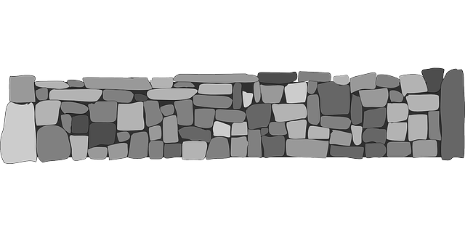
Notice this foundation is made of R.O.C.K.!
Reliable
Outgoing
Consistent Communicator
Knowledgeable
All of you can be that person that others look to for help to guide them through the journey of the Auxiliary. Be that person. Be that ROCK!

Please, have your Auxiliary represented at workshop in Jamestown, September 19, 2020, at the Quality Inn. At the workshop we will cover the purpose of mentoring. The purpose is to:
- Help those who need a little push to create mentoring teams in the Auxiliary.
- Help those who need a starting point to mentor.
- Give encouragement to those who have wanted to mentor but are not sure how to begin.
By belonging to the VFW Auxiliary, we are honoring our Veterans. Since Biblical times we have had Mentors and this tradition has continued to the present day.
We honor this organization and our Sisters by continuing our Mentoring.

For your Auxiliary to be successful this year you only have 4 questions on your yearend report. Please, review ASAP. Nice way to include this program in your activities. My recommendation for you are:
- Involve as many Sister as you can in your activities
- Host a Mentoring for Leadership Program
- Use the Mentoring at VFW Auxiliary-Relationship Building for the Future
- Resources available on the National Web Site
There is a video available “Understanding VFW Traditions.” Under Americanism
At vfwauxiliary.org/resources.

We,
“Salute to Our Veterans, Who Made this the Land of the Free”
As we are:
“Honoring Our Mission to Serve Veterans”

