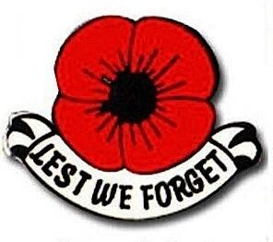 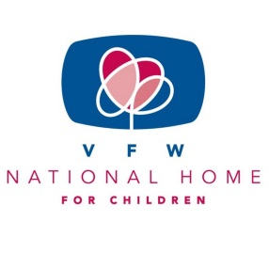

“BUDDY” POPPY/NATIONAL HOME FOR CHILDREN

Hello Auxiliary Members,

Wow…the last couple of months have been ones for the record book. We are hoping everyone is staying healthy, following social distancing and keeping our nation in your prayers as we all navigate this pandemic.

As we safely move forward with our upcoming year, take the time to explore the resources that are in the program books and on Malta. Brainstorm with your Auxiliary members on ways to incorporate “Buddy” Poppy/VFW National Home for Children into the other programs. We can always find ways to educate our communities about how important these two programs are. Have ready to hand out the story of the “Buddy” Poppy and the history of the National Home. There are probably many people who have never read about either or have forgotten. Now is the time to educate. If your Auxiliary is able to send in an additional donation to the National Home over and above the required Health and Happiness please do so. Every little bit helps and those little bits add up to big bits! Just like those three little pieces of the “Buddy” Poppy add up to so much more.

As we look forward to a new Auxiliary year, everything that we do as an Auxiliary helps our veterans and their families. Thank you to all for your hard work and dedication this past year to serving our veterans, active-duty military and their families. Working as a team we gave back to those who gave so much.

Stay well, stay safe and God Bless.

Mary Kay Hanson

[jmhanson@gra.midco.net](mailto:jmhanson@gra.midco.net)

Barb Heap

[barbheap@gmail.com](mailto:barbheap@gmail.com)

Serving Our Veterans with Aloha and

Marching Forward to Serve and Honor our Veterans

