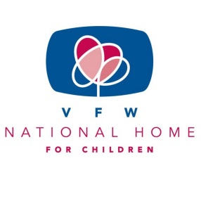

“BUDDY” POPPY/NATIONAL HOME FOR CHILDREN

Happy July, Happy Summer!

Greetings Auxiliary Members!

First of all I would like to thank President Joyce for asking me to take a chairmanship. I am happy to be a part of her team for 2020-2021. I think this will turn out to be a unique year as we all work to stay safe amid Covid-19.

There isn’t a beginning without an ending. There isn’t an ending without a beginning. Another Auxiliary year is beginning as another year has ended. A new beginning means another year of working our Auxiliary programs. This year will be a challenge to all of us. We will as a collective group, need to rethink how we can support our Veterans and their families, work our programs and continue to stay safe.

For the upcoming year, I will be passing along information on the “Buddy” Poppy and VFW National Home. Take this information back to your Auxiliaries, incorporate it into your other programs, and educate your old and new members of the importance of the little “Buddy” Poppy and the National Home. Educate our communities. Publicize “Buddy” Poppy and National Home on your Department and Auxiliary Facebook pages and websites and other social media. While doing all these wonderful things, don’t forget to keep track so you will be able to report everything at the end of the year. Review the year-end report now so you are familiar it. For example “Did your Auxiliary make a donation to the National Home NOT including Health & Happiness Donation?” All it takes is an extra $5.00, $10.00, $20.00 etc. to be able to say YES to this question. That is fairly easy to do. Your Auxiliary could take up a collection, raffle something and the money go towards the National Home. The ideas are endless to raise a little more money to send to the National Home. As the Home relies on donations and no government funding, everything helps them and counts on your report.

Due to Covid-19 many things have changed. That doesn’t mean we can’t work our programs. We just have to think differently. I’m excited to see all the ways our Auxiliaries have thought differently to incorporate the “Buddy” Poppy and National Home into their other programs and activities.

Barb Heap

Department Chairman

[barbheap@gmail.com](mailto:barbheap@gmail.com)

701-775-0478

“Salute to Our Veterans Who Made This The Land Of The Free

while

“Honoring Our Mission to Serve Veterans”

