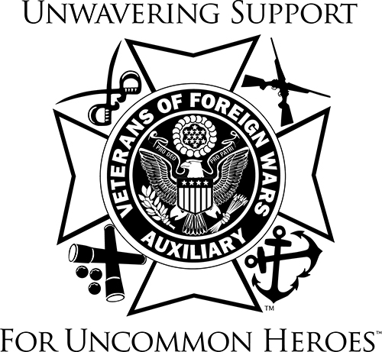 

VETERANS & FAMILY SUPPORT PROGRAM

Hello Auxiliary Members;

In the last couple of months, who would have thought that social distancing would become the new normal? I hope you and your loved ones are safe and well.

During these times serving our veterans and their families can be challenging. We need to really put on our thinking caps on how to stay connected and not physically be in the same area. That is a tough situation for all of us. You can send cards, phone calls, texts, emails etc. to stay in touch and to let others know you are thinking of them. If you are able to run errands, maybe there is a veteran or a member of their family you would be able to help out. Contact the Veterans Home and Hospital to see if there is some way you would be able to help out. Have information about what the Veterans & Family Support Program has to offer available to distribute to someone if they need help. It will take all of us working together to get through this. Our Veterans and their families need to know that we are here to help and support them.

Thank you to every member for your hard work and dedication to serving our veterans, active-   
duty military and their families this year. Each act, no matter how big or small did make a difference in someone’s life.

Stay safe, stay well and God Bless

Barb Heap

[barbheap@gmail.com](mailto:barbheap@gmail.com)

Serving Our Veterans with Aloha and

Marching Forward to Serve and Honor our Veterans

