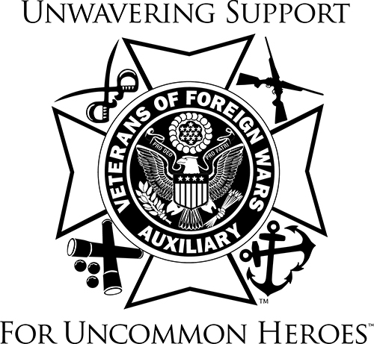 

VETERANS & FAMILY SUPPORT PROGRAM

Hello Auxiliary Members;

“The Hardest Part was asking for Help” “Veteran Keeps Her Home Thanks to Unmet Needs Grant” “Lending a Helping Hand”, “It Meant a Lot” Those are headlines that were printed in the VFW Magazine. Take from personal stories of Veterans and Veterans families that were helped with the Programs we as Auxiliary members help to support.

Many of us know how important troop support is because many of us have experienced military life as a spouse, child, parent or sibling of a solider. VFW Auxiliary members support our military community in many different ways. The two programs listed below; Military Assistance Program (MAP) and Unmet Needs are offered through the national VFW and promoted by the Auxiliary.

**MAP – Military Assistance Program**

This program is the outstretched hand between the local VFW and military community, offering support around the world. A large part of MAP is the Adopt-a-Unit program, providing VFW Posts and their Auxiliaries the opportunity to adopt hundreds of military units around the world. The goal is to develop supportive relations with the units before, during and after deployments to help deliver the vast network of resources the VFW has available to the military. For more information, visit the VFW website [www.vfw.org](http://www.vfw.org).

**UNMET NEEDS**

This program provides grants, not loans of financial aid up to $1500 to active-duty service members, veterans and their families to assist them with basic life needs. This money does not need to be repaid and the funds are paid directly to the creditor. Eligibility requirements to qualify are as follows;

1. Currently on active duty, whose financial hardship is a result of a current deployment, military pay error, or from being discharged for medical reasons.
2. Discharged on or after September 11, 2001, whose financial hardship is a direct result of your military service connected injuries and/or illnesses that are causing an employment hardship.
3. Discharge prior to September 11, 2001, who are on a fixed income (VA compensation, SSI, SSDI) and/or your financial hardship is an emergency situation.

As we go about our activities, if you or someone you in your Auxiliary, meets a service member, veteran and/or veteran’s family and you think they might qualify, help them to search [www.vfw.org/assistance/financial-grants](http://www.vfw.org/assistance/financial-grants). This application is only online. We have these programs available, and we need to get the information out!

**National President’s Special Project: Service Dog Training Program**

Below is a quarterly update on this special program. Half way through the Program Year and the goal of raising $25,000 has been reached and surpassed by:

* 214 Auxiliaries & 3 Posts
* 10 Individuals
* 12 Departments
* 6 Districts

The above have made donations in the amount of $39,565.87 for this special project! To date, five (5) veterans have been matched with a K-9. Thank you to all who have supported this program and helped the program help more veterans. For more information, check out Malta under Resources, Veterans and Family Support.

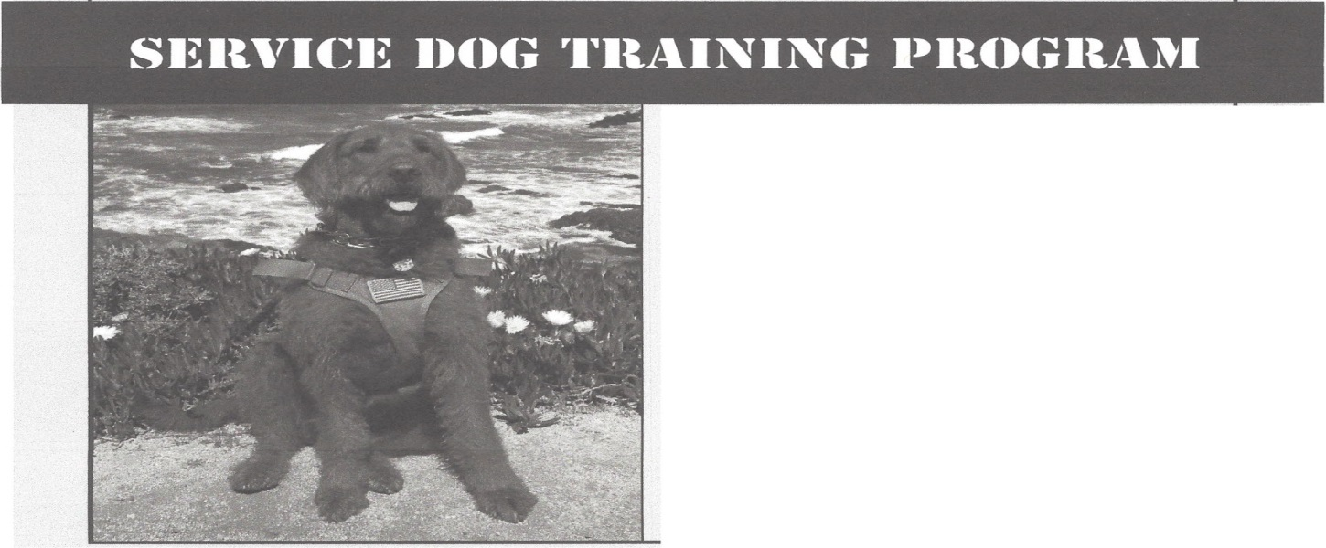

**DONATE BY MAIL**

Make check payable to:

VFW Department of California Foundation   
Earmark: VFW Service Dog Program

Mail check to:

VFW Department of California Foundation   
c/o VFW Service Dog Program

9136 Elk Grove Blvd., Suite 100

Elk Grove, CA 95624

I encourage your Auxiliary to order and distribute the Fact Sheets and the VFW Auxiliary Resource Rack Card – they are good resources to hand out at your community events, meetings, “Buddy” Poppy drives, etc. When you read the numbers on the fact sheet, we can and should be proud of all that we have done as Auxiliaries to help our Veterans and their families. The fact sheets are free and you can find the order form in Malta under Resources, Membership, VFW Auxiliary Brochure Order form.

There are so many opportunities to help veterans and their families this year. Work with your   
members to continue educating them and the community. All members are encouraged to   
become familiar with the areas within the Veterans & Family Support Program and be able to   
direct a veteran and/or his/her family in need of services.

Thank you to every member for your hard work and dedication to serving our veterans, active-   
duty military and their families. Each act, no matter how big or small makes a difference.

Barb Heap

[barbheap@gmail.com](mailto:barbheap@gmail.com)

Serving Our Veterans with Aloha and

Marching Forward to Serve and Honor our Veterans

