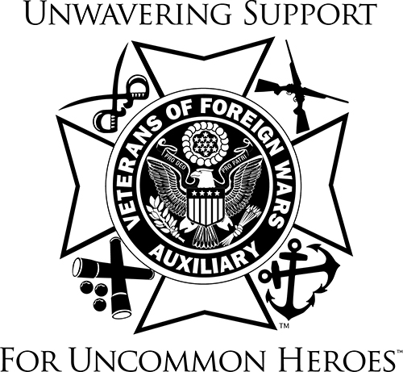 

VETERANS & FAMILY SUPPORT PROGRAM

Happy Belated Thanksgiving, Merry Christmas and Happy New Year

By the time you receive this General Orders, many of you will be in full swing of your Holiday planning, programs, baking etc. November traditionally starts the holiday season but it’s never too late to plan ways to brighten what may be an especially difficult time for our deployed service members and their families.

By working together, we can provide joy to our deployed service members and their families.

* Send care packages to deployed service members. Invite each Auxiliary member to bring a small non-perishable treat or sample size health/beauty item to your next meeting. Pick up a flat rate box (they’re free from your local Post Office). Fill the box and pay a flat rate for shipping
* Host Holiday and Christmas events for the families of those deployed
* Gift the gift of time. From meals to running errands to conversation and companionship, these gifts can be given to those who could use a helping hand
* Give Thank You coins and post Resource Rack Cards.
* Send Operation Uplink Virtual Pins to those deployed or in hospitals
* Collect non-perishable food items, make and deliver food baskets to those in need
* Discuss having a Warm the Heart Drive. Collect blankets, gloves, hats, socks and/or warm clothing to give to those in need

Getting the word out about everything we do is important too. Post information on your social media accounts; include information in newsletters, your local newspapers, radio, etc. Take pictures and share them. And after all the good things your Auxiliary has done, don’t forget to report it!

Also, I would like to remind you of the resources listed in Malta. Take a few minutes and learn about the different ways we can support our Veterans and their families.

VFW’s Veterans & Military Support Program:

* Unmet Needs – Financial Assistance
* Military Assistance Program (MAP)
* Adopt-A-Unit
* VFW’s Sport Clips Help a Hero Scholarship
* Virtual Pin Request Form

Thank you to every member for your hard work and dedication to serving our veterans, active-duty military and their families. Each act, no matter how big or small makes a difference.

Barb Heap

[barbheap@gmail.com](mailto:barbheap@gmail.com)

Serving Our Veterans with Aloha and

Marching Forward to Serve and Honor our Veterans

