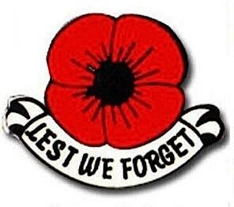 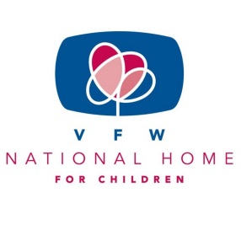

“Buddy” Poppy / VFW National Home for Children

Program

Buddy Poppy

The Program Goals for 2019-2020 year are as follows:

1. Buddy Poppy Display Contest

2. Incorporation of the Buddy Poppy into other Programs

3. Buddy Poppy Education and Community Outreach

We, as Auxiliaries, can reach these goals by:

1. By doing a Buddy Poppy display at Department Convention with the hope of qualifying for the National Convention.

The displays must fit in one of the following categories:

1. a. Category 1-Public Promotion of Buddy Poppy campaign
2. b. Category 2-Memorial or Inspirational display
3. c. Category 3-Artistic or Decorative use of Buddy Poppies

2. Include a Buddy Poppy when distributing cards or gift bags to hospitalized veterans, wrapping one around a small flag that is being distributed, add to decorations or centerpieces, handing them out at parades etc.

3. Encourage EVERY Auxiliary in each District to order BUDDY POPPIES and have a Buddy Poppy drive. You may have as many drives as you choose.

4. Hand out material at Poppy drives to educate the community of the importance of the Buddy Poppy and the Veterans behind them.

Mary Kay Hanson

[jmhanson@gra.midco.net](mailto:jmhanson@gra.midco.net)

Barb Heap

[barbheap@gmail.com](mailto:barbheap@gmail.com)

Serving Our Veterans with Aloha and

Marching Forward to Serve and Honor our Veterans

