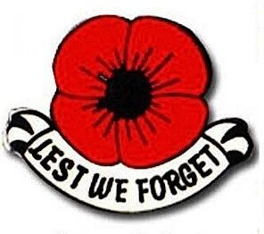 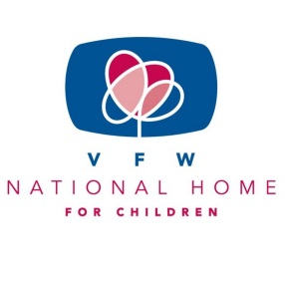

“BUDDY” POPPY/NATIONAL HOME FOR CHILDREN

Hello Auxiliary Members,

As the year ends, Mary Kay and I would like to thank President Barb for this opportunity to help spread the word and information about “Buddy” Poppy and the National Home to our Auxiliaries. I would personally like to thank Mary Kay for her mentorship. This was my first program I have been Department Co- Chairman of. A year of learning for me!

We had 22 Auxiliaries send in yearend reports. We had 33 “Buddy” Poppy drives with the Post and 17 without the Post. We had 10 Auxiliaries enter the “Buddy” Poppy display and 10 that used the “Buddy” Poppy manual. For the National Home only 8 Auxiliaries promoted it, 6 promoted the Helpline and 12 Auxiliaries gave extra donations above the Health and Happiness requirement to the tune of $910.00! Thank you to those Auxiliaries for that extra donation.

In the upcoming year, our Auxiliaries need to work to promote the “Buddy” Poppy and the VFW National Home for Children. We need to use those 3 little pieces of the “Buddy” Poppy and continue to incorporate them into all our National Programs. This flower supports our Veterans Service Fund and our VFW National Home. We need to dig out those boxes of “Buddy” Poppies and use them. Every single program could use a “Buddy” Poppy. We need to support the National Home by an extra donation above the requirement. No matter how small a donation, it is reportable and it counts. Since 1925 the VFW National Home has been around. It was because of people and Auxiliaries like you.

Again, thank you to all Auxiliaries for your hard work to support our veterans and military families.

Stay well, stay safe and God Bless.

Mary Kay Hanson

[jmhanson@gra.midco.net](mailto:jmhanson@gra.midco.net)

Barb Heap

[barbheap@gmail.com](mailto:barbheap@gmail.com)

Serving Our Veterans with Aloha and

Marching Forward to Serve and Honor our Veterans

