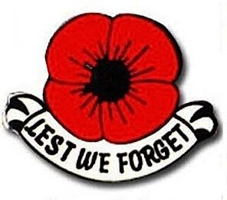 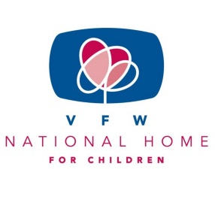

“BUDDY” POPPY/NATIONAL HOME FOR CHILDREN

Happy Belated Thanksgiving, Merry Christmas and Happy New Year

As we join this holiday season with our families and friends, social and church groups, school groups, book club groups, quilting groups, lefse making groups, car groups, Auxiliary and Post groups, etc. Whatever function that you are involved in, take time to stop, look around and remember we are walking this path called life together. We help, support, nourish, encourage, cry and laugh with one another. This is something that should be done throughout the year and not just at the holiday season.

Part of this walk along life is supporting our Auxiliary Programs. That is why when we read the VFW Auxiliary National Programs Blog from our National Ambassador; we were shocked to learn that “Buddy” Poppy sales are DOWN. Down by half a million. Half a million. I had to let that sink in for a minute. She also went on to write that three “Buddy” Poppy assembly locations have closed due to the lack of purchases. Wow. How can we continue to support our Veterans, our military and our VFW National Home for Children at this pace?

Yes, what Auxiliary doesn’t have a cache of “Buddy” Poppies in their storage closets? If you do have multiple boxes, you are not using the “Buddy” Poppy the way they were intended. THEY NEED TO BE USED and REPLENISHED. We should be:

* Hosting “Buddy” Poppy drives
* Using “Buddy” Poppies at all our holiday and fundraising events
* Decorating gifts for our hospitalized veterans with “Buddy “ Poppies
* Including “Buddy “ Poppies in care packages to our military
* Decorating gifts/awards for our youth and scholarship contestants with “Buddy” Poppies
* Including “Buddy” Poppies with Flags that are handed out in our communities
* Including “Buddy” Poppies in photos sent to our local newspaper
* Including “Buddy” Poppies in letters sent to our legislative representatives

Our members need to be reminded that for each “Buddy” Poppy purchased:

* One-and-a-half cents go to your Department’s Veterans Service Fund
* One cent goes to VFW National Headquarters Veterans Service Fund
* One cent goes to the VFW National Home for Children

Without this money going to the above organizations, who will take care of our veteran’s needs? Who will give our military and veteran children the happy family they deserve? We need to dig out those boxes of “Buddy” Poppies. Use them. Replenish them and then keep on using them. The “Buddy” Poppy has been the official flower since 1922. That’s almost one hundred years. That’s a lot of money raised by those three little parts of a“Buddy” Poppy. We encourage all Auxiliaries to find those “Buddy” Poppies, use them, and replenish them. Report to us how you have used them. Use them every year, replenish them every year. We need to continue this support.

Thank you to all for your hard work and dedication to serving our veterans, active-duty military and their families. Working as a team we can give back to those who gave so much.

Mary Kay Hanson

[jmhanson@gra.midco.net](mailto:jmhanson@gra.midco.net)

Barb Heap

[barbheap@gmail.com](mailto:barbheap@gmail.com)

Serving Our Veterans with Aloha and

Marching Forward to Serve and Honor our Veterans

