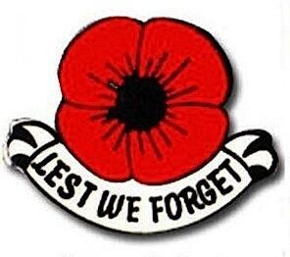 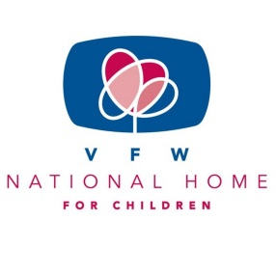

BUDDY POPPY/NATIONAL HOME FOR CHILDREN

Hello Auxiliary Members!

We were honored to have been asked by President Barb Danielson to assist in her 2019-2020 year as Co-Chairs for the Buddy Poppy/National Home Program.

These two programs are possibly the oldest and most well-known programs of our organization. We will do our best to offer ideas and suggest promotions to help you throughout the upcoming year.

The saying “Every Day is Poppy Day” is actually very true. Per National Headquarters we can distribute poppies every single day not just Memorial Day and Veterans Day. Your Auxiliary can decide how to make the most out of the Buddy Poppy Program.

The VFW National Home for Children in Eden Rapids, Michigan has been around for over 90 years. It serves as a living memorial to America’s veterans by helping our nation’s military and veteran families during difficult times. It’s a place to help keep the family circle together.

Along with our National Program Ambassador, we want to help the Auxiliaries promote, educate and use the resources available to make our communities aware of these two very important programs. We are excited to attend National Convention in Orlando to bring back ideas and pass them onto the Auxiliaries.

We will see everyone at the fall workshop on August 10 in Jamestown.

Mary Kay Hanson

[jmhanson@gra.midco.net](mailto:jmhanson@gra.midco.net)

Barb Heap

[barbheap@gmail.com](mailto:barbheap@gmail.com)

Marching Forward to Serve and Honor our Veterans

